**LOAN APP**

Gonzales, Joyce Nicole M.

Pelo, Efren Miguel B.

Arimuhanan, Karen B.

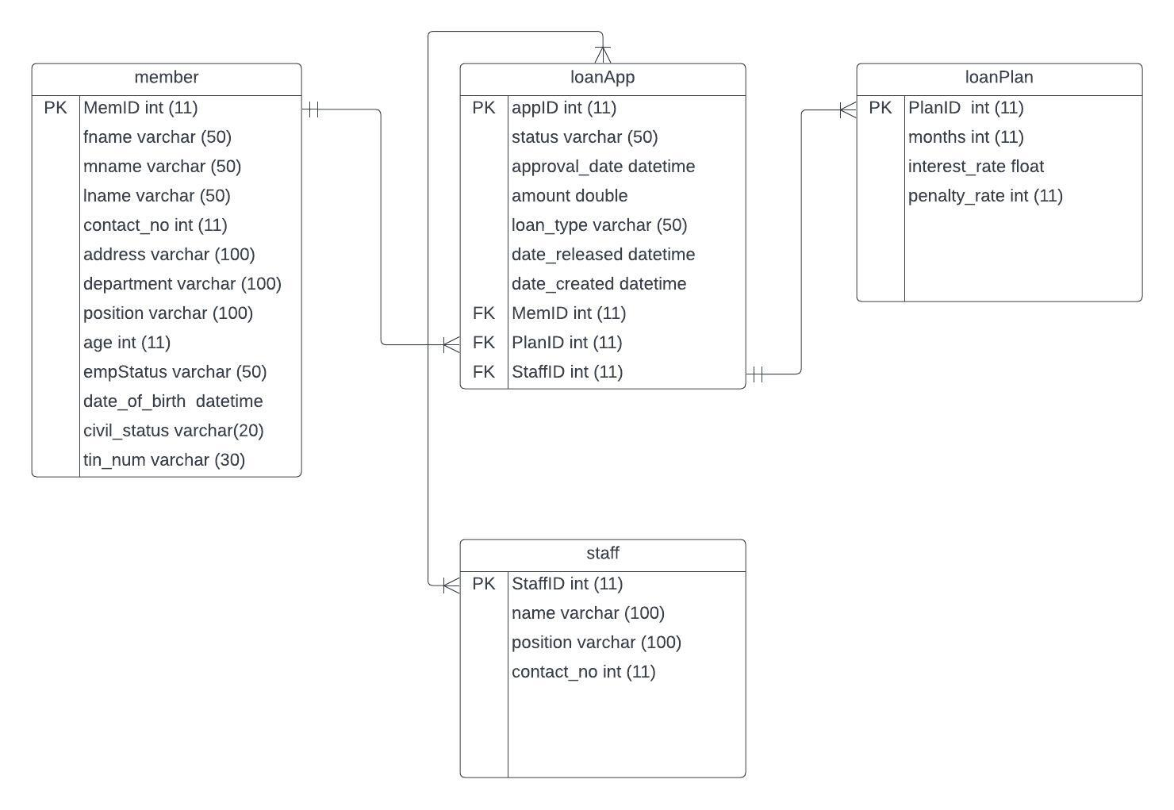Data Mapping

*Submission of Loan Applications:*

This process consists of four tables: members, loan application, loan plan, and staff. In this process, members will submit loan applications which can then be accessed by staff members for review and approval. The staff members have the authority to review and approve multiple loan applications.

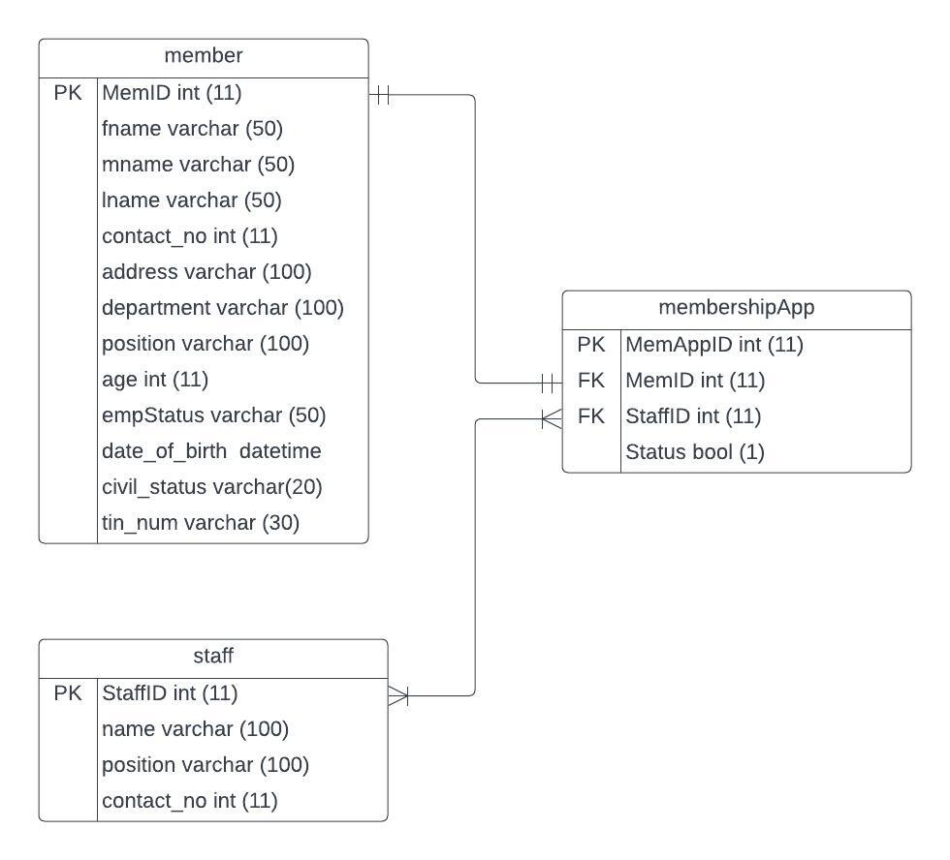

*Submission of Membership Applications:*

This process involves three tables: member, staff, and membershipApp. During this process, members will submit membership applications that can be accessed by staff members for the purpose of reviewing and approving them.

**DATA DICTIONARY**

Members (member) Table

|  |  |  |  |
| --- | --- | --- | --- |
| Attribute Name | Data Type | Field Length | Description |
| MemID | Int | 11 | Member ID, Auto-generated |
| fname | Varchar | 50 | First name of the member |
| mname | Varchar | 50 | Middle name of the member |
| lname | Varchar | 50 | Last name of the member |
| contact_no | Int | 11 | Contact number of the member |
| address | Varchar | 100 | Address of the member |
| department | Varchar | 100 | Department of the member |
| position | Varchar | 100 | Position of the member |
| age | Int | 11 | Age of the member |
| empStatus | Varchar | 50 | Employee status of the member |
| date_of_birth | Datetime |  | Date of birth of the member |
| civil_status | Varchar | 20 | Civil Status of the member |
| tin_num | Varchar | 30 | Taxpayer Identification Number (TIN) of the member |

Loan Application (loanApp) Table

|  |  |  |  |
| --- | --- | --- | --- |
| Attribute Name | Data Type | Field Length | Description |
| AppID | Int | 11 | Application ID, Auto-generated |
| status | Varchar | 50 | Status of the loan application |
| approval_date | Datetime |  | Date approval of the loan application |
| amount | Double |  | Principal amount of the loan |
| loan_type | Varchar | 50 | Classification of the loan |
| date_released | Datetime |  | Date of loan application submission |
| date_created | Datetime |  | Date of loan application creation |
| MemID | Int | 11 | Foreign Key to Member MemID |
| PlanID | Int | 11 | Foreign Key to loanPlan PlanID |
| StaffID | Int | 11 | Foreign Key to Staff StaffID |

Loan Plan (loanPlan) Table

|  |  |  |  |
| --- | --- | --- | --- |
| Attribute Name | Data Type | Field Length | Description |
| PlanID | Int | 11 | Plan ID, Auto-generated |
| months | Int | 11 | Duration of the loan repayment period |
| interest_rate | Float |  | Percentage of the loan amount |
| penalty_rate | Int | 11 | Overdue payment penalty of the member |

Staff (staff) Table

|  |  |  |  |
| --- | --- | --- | --- |
| Attribute Name | Data Type | Field Length | Description |
| StaffID | Int | 11 | Staff ID, Auto-generated |
| name | Varchar | 100 | Full name of the staff |
| position | Varchar | 100 | Position of the staff |
| contact_no | Int | 11 | Contact number of the staff |

Membership Application (membershipApp) Table

|  |  |  |  |
| --- | --- | --- | --- |
| Attribute Name | Data Type | Field Length | Description |
| MemAppID | Int | 11 | MemApp ID, Auto-generated |
| MemID | Int | 11 | Foreign Key to Member MemID |
| StaffID | Int | 11 | Foreign Key to Staff StaffID |
| Status | Boolean | 1 | Status of loan application |